**JVM / JRE – How to Install**

**Pre-requisites:**

Verify in the VM, the JVM/JRE is installed or not



**Step #1:** run the below command in the VM

$ sudo yum install jre -y

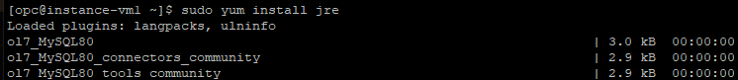

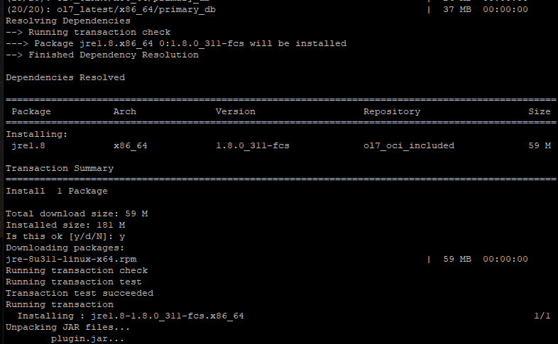

Now successfully installed

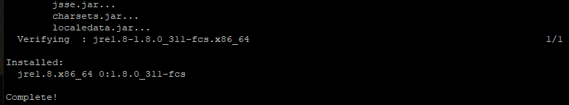

**Step #2 :** verify as below is successfully installed the JVM/JRE

